Lab#2

**Objective**: To become Familiar with Stream Socket.

**Task1**: Compile and run the above code. Start the acceptor first and then the requestor with appropriate command line arguments. Describe and explain the output.

**Acceptor Code:**

import java.io.*;

import java.net.*;

class ConnectionAcceptor{

public static void main(String args[]){

//two command lines are required

if(args.length!=2){

System.out.println("This program required 2 command line argument.");

}

else{

try{

int portNo=Integer.parseInt(args[0]);

String messege=args[1];

ServerSocket connectionSocket=new ServerSocket(portNo);

System.out.println("now ready to accept connection");

Socket dataSocket=connectionSocket.accept();

System.out.println("Connection Accepted");

OutputStream outStream=dataSocket.getOutputStream();

PrintWriter socketOutput=new PrintWriter(new OutputStreamWriter(outStream));

Thread.sleep(5000);

socketOutput.println(messege);

socketOutput.flush();

System.out.println("messege sent");

dataSocket.close();

System.out.println("datasocket closed");

connectionSocket.close();

Thread.sleep(1000);

}catch(Exception ex){

System.out.println(ex);

}

}

}

}

**ConnectionRequestor Code:**

**import java.io.*;**

**import java.net.*;**

class ConnectionRequestor{

public static void main(String args[]){

if(args.length!=2){

System.out.println("This program requiers 2 command line arguments");

}

else{

try{

//192.168.0.107 ipv4

InetAddress hostAcceptor=InetAddress.getByName(args[0]);

int acceptorPort=Integer.parseInt(args[1]);

Socket mySocket=new Socket(hostAcceptor,acceptorPort);

System.out.println("Connection request granted");

InputStream input=mySocket.getInputStream();

BufferedReader reader=new BufferedReader(new InputStreamReader(input));

System.out.println("reading in process");

String msg=reader.readLine();

System.out.println("msg recieved:"+msg);

mySocket.close();

System.out.println("socket closed");

Thread.sleep(10000);

}

catch(Exception e){

e.printStackTrace();

}

}

}

}

**Task1 snaps:**

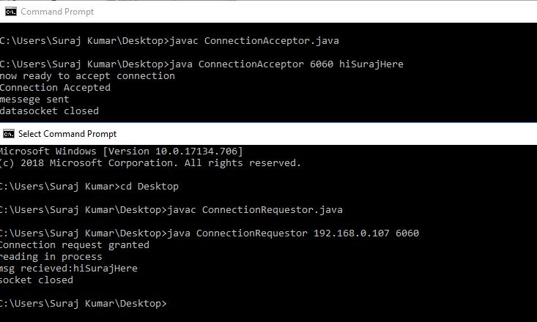

**OutPut Explaination:** It is working nicely, this msg “hiSurajHere” is being sent by using 6060 port number. And it is received same on other side.

Task2:

Now run the code again, but reverse the order of program’s execution. Start the requestor first and then the acceptor. Describe and explain the outcome.

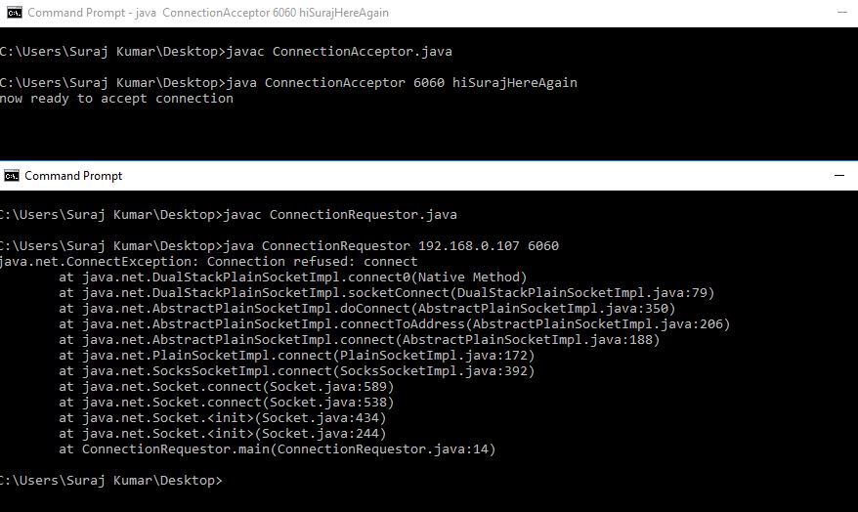

**Output Explaination**: Whenever I started ConnectionRequestor first it gives an Exception “java.net.ConnectException” Connection refused.

**Task3:**

ConnectionAcceptor:

import java.io.*;

import java.net.*;

class ConnectionAcceptor{

public static void main(String args[]){

//two command lines are required

if(args.length!=2){

System.out.println("This program required 2 command line argument.");

}

else{

try{

int portNo=Integer.parseInt(args[0]);

String messege=args[1];

ServerSocket connectionSocket=new ServerSocket(portNo);

System.out.println("now ready to accept connection");

Socket dataSocket=connectionSocket.accept();

System.out.println("Connection Accepted");

OutputStream outStream=dataSocket.getOutputStream();

PrintWriter socketOutput=new PrintWriter(new OutputStreamWriter(outStream));

**Thread.sleep(5000); //delay before msg written**

socketOutput.println(messege);

socketOutput.flush();

System.out.println("messege sent");

dataSocket.close();

System.out.println("datasocket closed");

connectionSocket.close();

Thread.sleep(1000);

}catch(Exception ex){

System.out.println(ex);

}

}

}

}

Out Put snaps:

Snap1: It is delaying 5 sec on requestor side

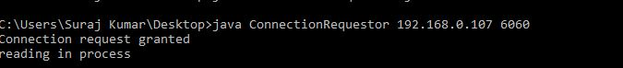Snap2:After delaying 5 sec